Report
- I put the thermal sensor into the SHG housing, connected the wires of thermal sensor and the Peltier with the thermal controller. Successfully monitored and controlled the temperature inside the housing.
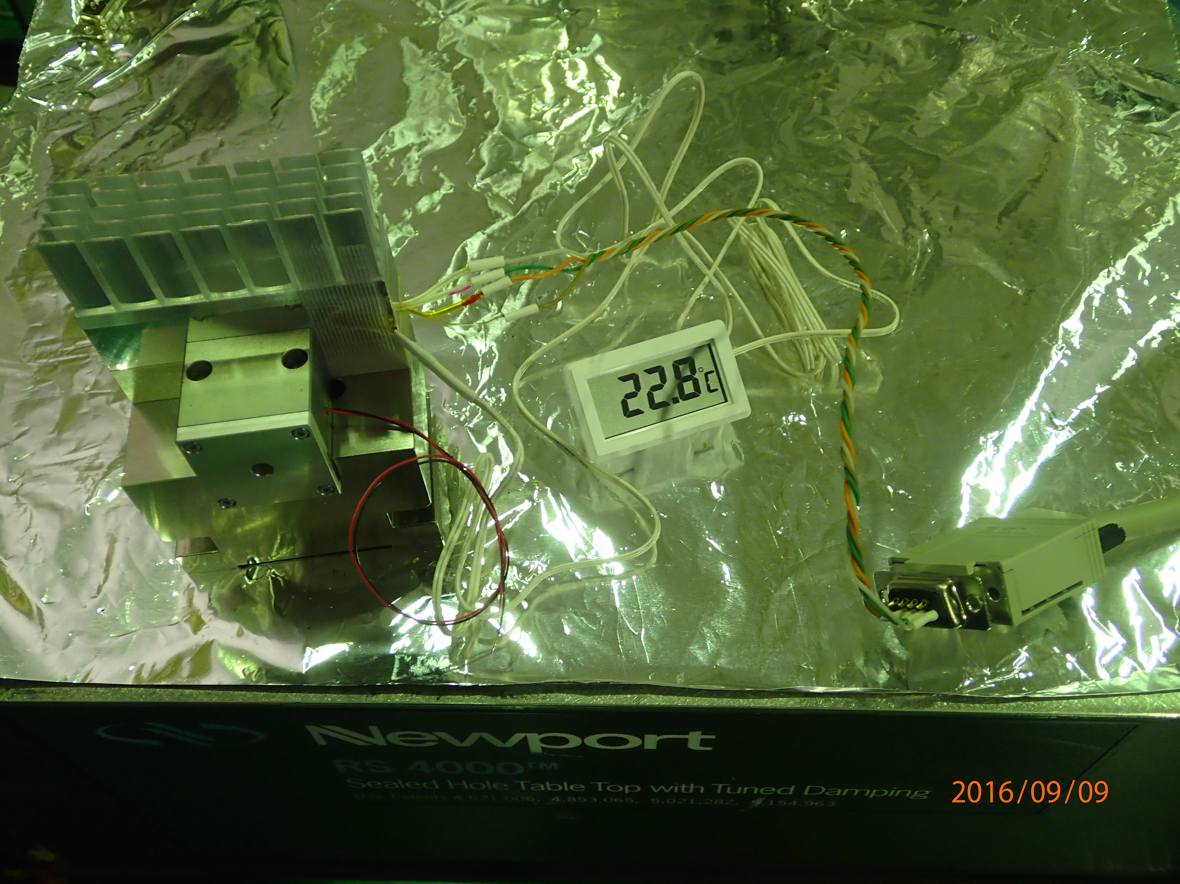
- I connected the wire of the PZT with the PZT driver. Using the simple Michelson interferometer on the ground floor of TAMA,firstly checked whether the system work or not, then got the transfer function of the PZT.
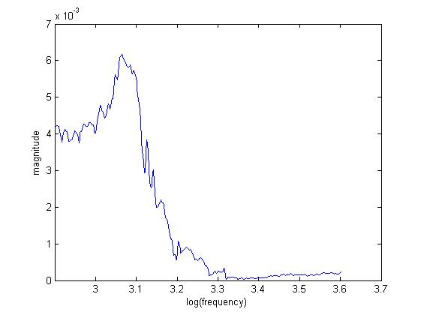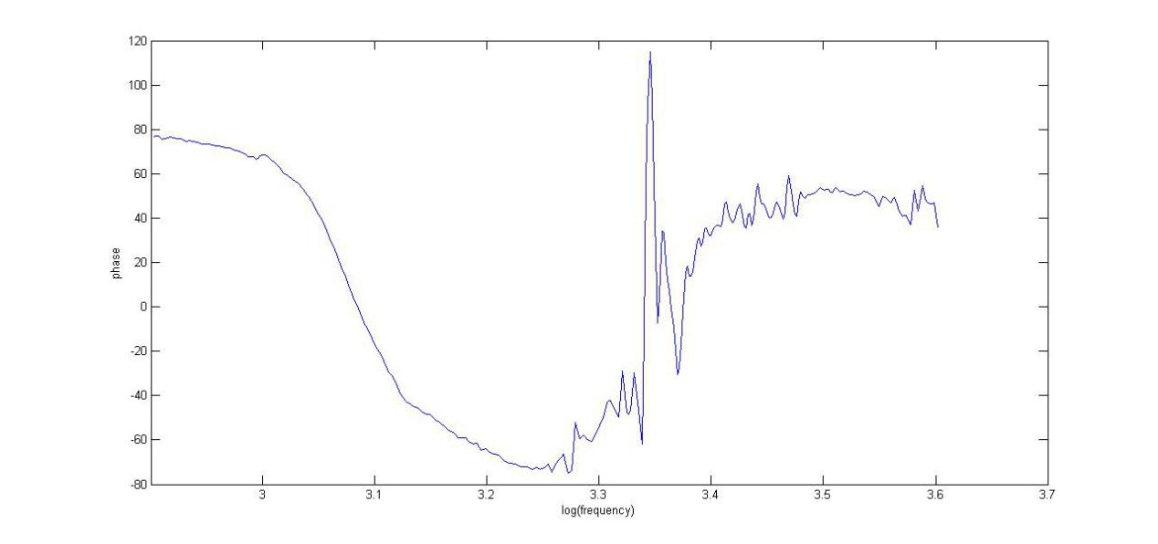
3.Since we need the crystal to work under about 67 degree, I gradually increase the temperature with the thermal controller, it worked well until 62 degree, but when I increased the limited current of the system, the wire of Peltier suddenly broke. And there is also other problems with the design of the housing, it has been sent back to the company to make some changing, I will continue this work when it comes back next week.

