**Report**

Yuefan Guo

Jan 20th, 2016

**Aim**: Find the position of beam waist of 1064nm laser

**Equipment**: 1. Laser

Model: Mephisto 2000NE

Diode A: I=2.01A T=19.00℃

Diode B: I=2.03A T=17.50℃

Output power@ 1064nm: 2.062W

2.Beam Master

Model: BM-3UV

3. Lens

Model: KPX 094

Focal length: 100.00

**Step:**

1. Before turn on the laser, check is needed. Firstly, the temperature of two diodes should equal to the setting value. Because the temperature is correlated with the wavelength of output signal. Then set the current of diode around 0A and put a screen or some other shelters, in case the high power laser directly shine on human or paper which might be burned.
2. Turn on the laser, increase the current to 0.8A to get a output power around 3mW.
3. Align the position of Beam Profiler let the beam’s height is near the receiving hole..
4. Change the distance between the head of Beam Profiler and the laser, taking larger step at first. Collect the data, z is the distance, D is the diameter of the beam, w and v represent different directions. Plot the data and try to find if there is a minimum of the diameter which means the beam waist.

**Data**

|  |  |  |
| --- | --- | --- |
| Z(cm) | Dw(μm) | Dv(μm) |
| 10 | 1423 | 1334 |
| 20 | 2059 | 1845 |
| 30 | 2516 | 2267 |
| 40 | 2913 | 2616 |
| 50 | 3370 | 2979 |

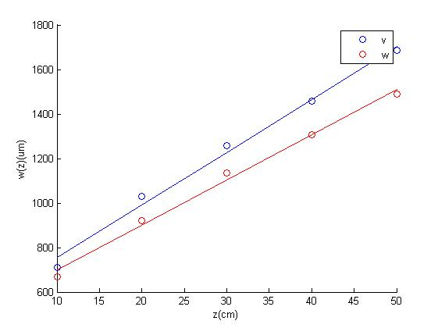

**Fig1**: The scatter plot of data, red circle represents the w direction and blue circle represents the v direction.

It is obvious the radius keep increasing with z, which means the beam waist is some how inside the laser. The solid line is the fitting line, with the following equation:



ω(z) is the radius of the beam, z0 is the position of beam waist and ω0 is the radius of beam waist, zR is Rayleigh range. Using the data, we can get the value of ω0 and z0. Then use the (Eq.1) and (Eq.2), get the fitting line.

|  |  |  |
| --- | --- | --- |
| Direction | ω0 (μm) | z0(cm) |
| w | 141.6 | -20.97 |
| v | 164.7 | -23.05 |

1. Add a lens in front of the laser. Align the height of laser, lens and the Beam Profiler. When the Gaussian beam traverse the lens, the properties of the beam changes, but it still has correlation with the original beam.

**Data**

|  |  |  |  |
| --- | --- | --- | --- |
| Z(cm) | Output power(mW) | Dw(μm) | Dv(μm) |
| 45 | 3.295 | 935 | 880 |
| 90 | 3.491 | 667 | 607 |
| 133 | 3.470 | 442 | 367 |
| 168 | 3.554 | 266 | 179 |
| 189 | 3.522 | 165 | 207 |
| 201 | 3.461 | 243 | 336 |
| 215 | 3.497 | 357 | 447 |
| 230 | 3.540 | 429 | 529 |
| 250 | 3.525 | 589 | 673 |
| 300 | 3.540 | 884 | 980 |

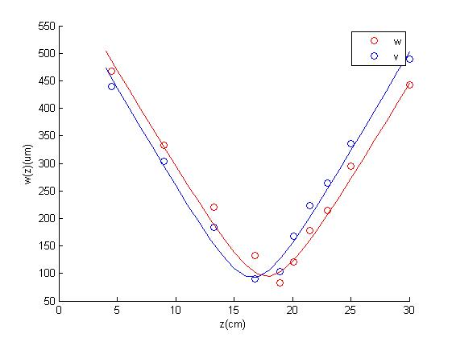**Fig2**: Put a lens(f=100.00) in front of the laser, collect the data and use the same method to get the fitting line as last step.

|  |  |  |
| --- | --- | --- |
| Direction | ω0 (μm) | z0(cm) |
| w | 94.77 | 17.83 |
| v | 91.87 | 16.58 |

1. Use the result of step 3 and calculate the theoretical value after putting a lens( f=100.00) in front of the laser with following equations.



The corner mark 1 represent the value of the beam before traverse the lens, the corner mark 2 represent the value of the beam after traverse the lens, d is the distance between lens and beam waist. Then we can use this equation to get the theoretical ω0 and z0. Plot experimental and theoretical result in one figure.

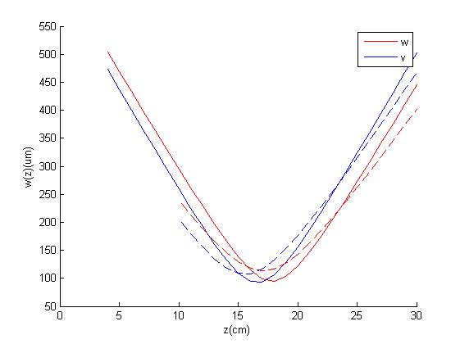

**Fig3**: The solid lines are the same with last figure, dashed lines represent the theoretical result.

**Theoretical result**

|  |  |  |
| --- | --- | --- |
| Direction | ω0 (μm) | z0(cm) |
| w | 113.5933 | 17.0597 |
| v | 107.5640 | 15.5662 |

**Result**:

From figure 3, the lines from two methods do not have a very obvious difference, so we can locate the beam waist is inside the laser, if we suppose the coordinate of laser head is z=0, then the beam waist location is around z=-20.97 and z=-23.05, and the radius of the beam is ω0=141.6 and ω0=164.7.