Report
Yuefan Guo
Jan 19th, 2016
Aim: 1.Find the correspondences between the current of diode and the output power of LASER.
2. Ensure the threshold value
Equipment: 1. Laser
Model: Mephisto 2000NE
Diode A: I=2.01A T=19.00℃
Diode B: I=2.03A T=17.50℃
Output power@ 1064nm: 2.062W
2.Photodetector
Model: S310C
Sense: 2.07537mV/W
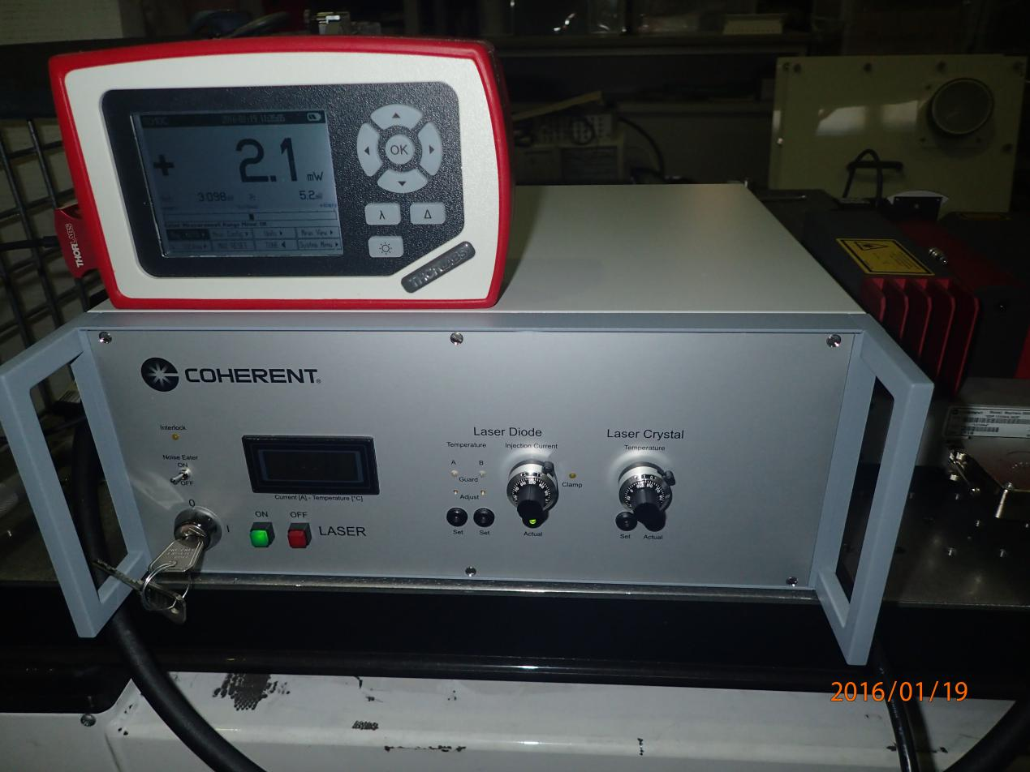
Up: The monitor of photodetector
Down: The control board of Laser
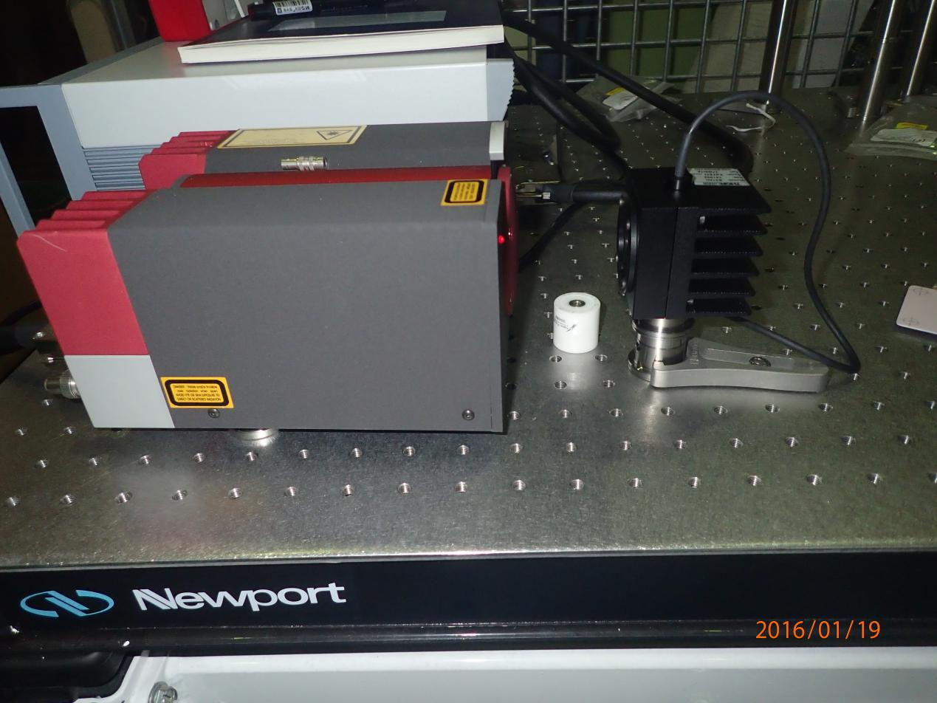
Left: The Laser
Right: The photodetector
Step:
- Before turn on the laser, check is needed. Firstly, the temperature of two diodes should equal to the setting value. Because the temperature is correlated with the wavelength of output signal. Then set the current of diode around 0A and put a screen or some other shelters, in case the high power laser directly shine on human or paper which might be burned.
- Align the position of photodetector, let the beam near the center of it to get high efficiency.
- Start to increase the current of diode, collect the data and try to get the correspondence and the threshold. Adjust the interval by the output power increasing. When I reach the maximum power, reduce the current gradually to the starting point.
- Turn off the laser and the photodetector thoroughly when the experiment is finished.

Data
Current(A) | Output Power(mW)
0.442 | 0.4
0.552 | 0.4
0.562 | 0.5
0.576 | 0.6
0.689 | 1.0
0.690 | 2.2
0.691 | 3.0
0.695 | 6.1
0.701 | 10.8
0.712 | 20.5
0.733 | 40.0
0.753 | 60.7
0.781 | 90.5
0.875 | 199.5
1.042 | 506
1.263 | 1010.0
1.594 | 1495.0
1.847 | 1801.0
1.935 | 1903.0
2.046 | 2027.0
2.049 | 2034.0
1.900 | 1864.0
1.802 | 1751.0
1.500 | 1375.0
1.201 | 882.0
0.903 | 243.9
0.800 | 112.2
0.701 | 13.5
0.689 | 3.3
0.688 | 2.1
0.632 | 1.7
0.481 | 1.7

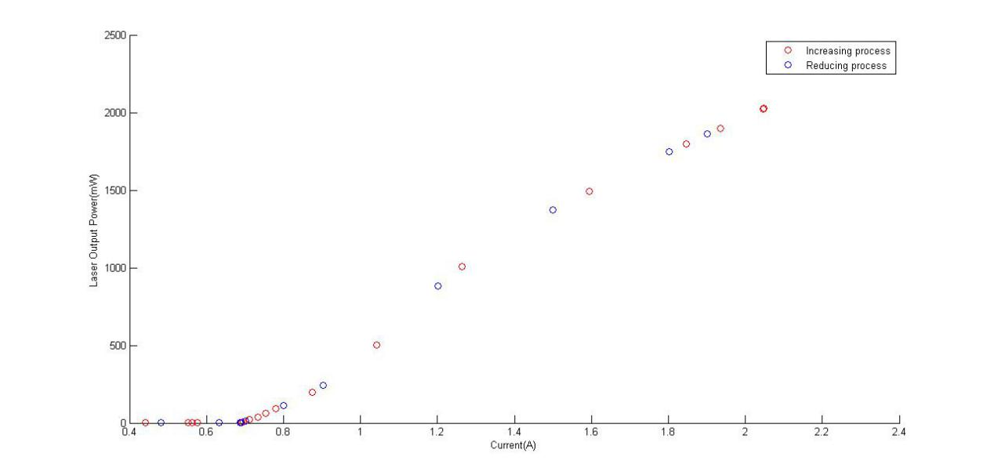
Fig1: The scatter plot of data, red circle represents the increasing process and blue circle represents the reducing.
Result:1. It is clear that the output power of laser has a maximum around 2W.
2. There is a slight peak around 1.4A which makes the slopes of the points beyond and
below the 1W are different.
3. Considering the response of the photodetector, we have the prediction of the
hysteresis, but according to the figure, there is no obvious hysteresis between power of
two process.
4. The threshold around 0.7A, below this value, when you keep reducing the current, the
output power does not have obvious change.

