Report
Find the relationship between laser output power and beam diameter.
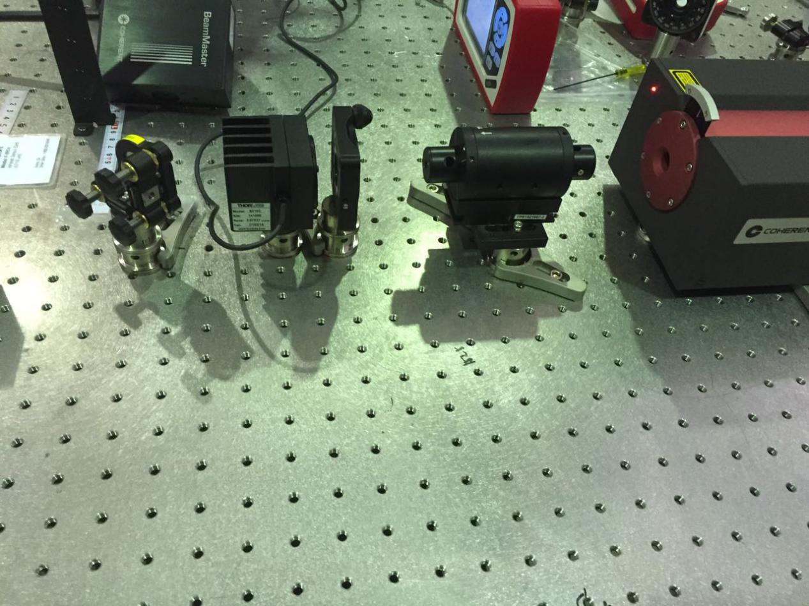
Power meter
1/2 waveplate
Faraday Isolator
Pic 1: With the equipment above, measure the output power of the laser.
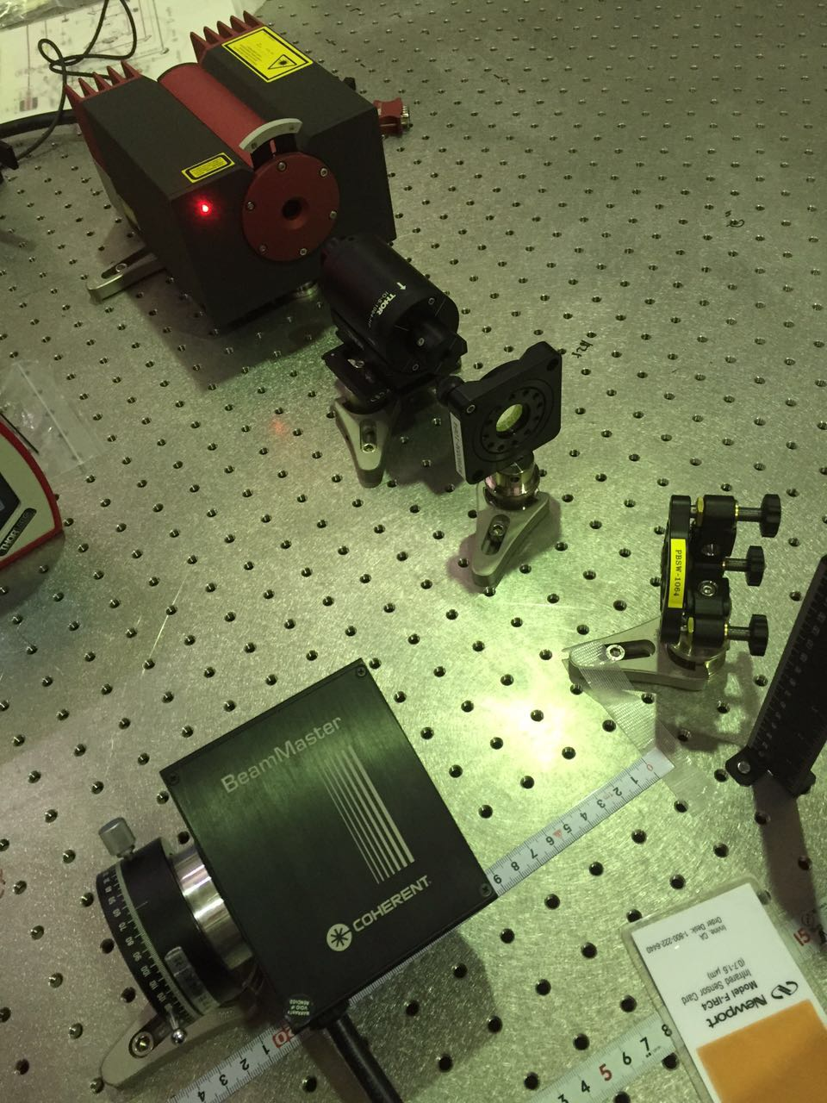
Beam Profiler
PBS
Pic 2: Take out the power meter and measure the beam size with beam profiler.
Data:
Power(W) | V(μm) | W(μm)
1.524 | 3488 | 3495
1.000 | 2778 | 2585
0.801 | 2392 | 2248
0.599 | 2344 | 2196
0.4015 | 2465 | 2323
0.2006 | 2910 | 2714
1.007 | 2753 | 2558
1.200 | 3067 | 2829
1.402 | 3337 | 3035
1.543 | 3552 | 3157
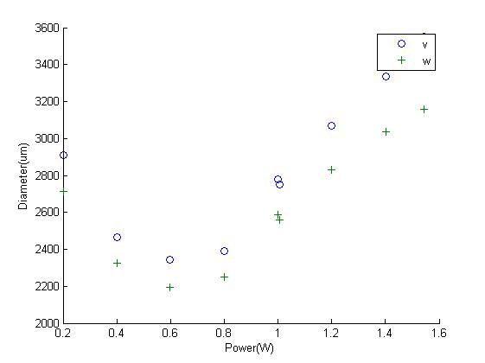

Power(W) | V(μm) | W(μm)
0.1001 | 3216 | 3035
0.2002 | 2923 | 2740
0.3006 | 2666 | 2495
0.3989 | 2502 | 2364
0.5005 | 2385 | 2259
0.6050 | 2333 | 2201
0.8000 | 2366 | 2227
0.9000 | 2483 | 2323
1.000 | 2686 | 2485
1.202 | 3018 | 2774
1.400 | 3255 | 2975
1.500 | 3392 | 3069
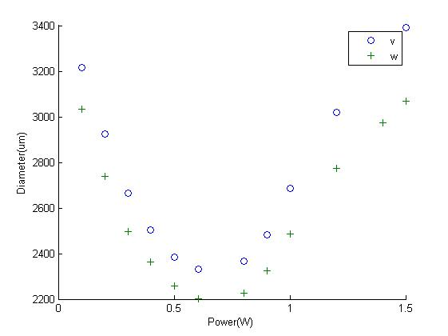
Result:
According to the figures, we can get the following result:
- The measurement of the first time and second time show exactly the same result, which means the laser is stable.
- We expected in the low power range, the size of the beam will keep constant, but it shows up with a very big changing.

Find the optimum position of lens to get smallest beam at the SHG
Z(cm) | V(μm) | W(μm)
5 | 2506 | 2323
10 | 2691 | 2488
15 | 2890 | 2670
20 | 3066 | 2839
25 | 3252 | 3005
30 | 3217 | 3217
35 | 3627 | 3343
40 | 3848 | 3550
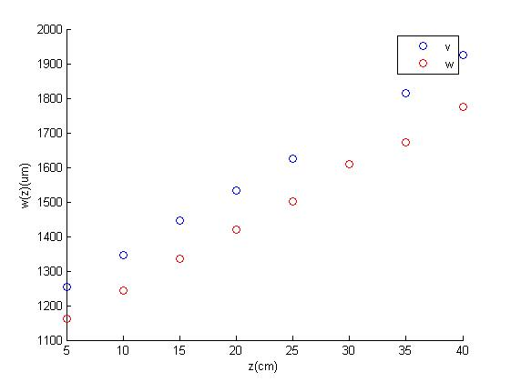
According to the data, get the information of the radius and the position of beam waist.
Direction | ω₀ (μm) | z₀(cm)
v | 192.2 | -59.88
w | 185.3 | -62.71
Choose the position of the lens with two conditions:
- The beam waist size should be less than 40μm when it arrives at the SHG.
- The distance between the lens and the SHG should be about 30cm to give other components space.
There are two variables in the calculation, the focal length of the lens and the distance between lens and laser head. According to the calculation, we can get two correspondences.
- The size of the beam waist after going through the lens will increase with the focal length.
- When the distance between the lens and the laser head increase, the size of the beam will reduce, at the same time the distance between the between the lens and beam waist will reduce.
So the best values for the two variables for now is 175mm and -5cm(reduced the disance between the PBS and 1/2 waveplate), with this value, the predicted beam radius is 78.1981μm in v direction and 86.3791μm in w direction with ABCD matrix method. The distance between lens and beam waist is about 25cm.
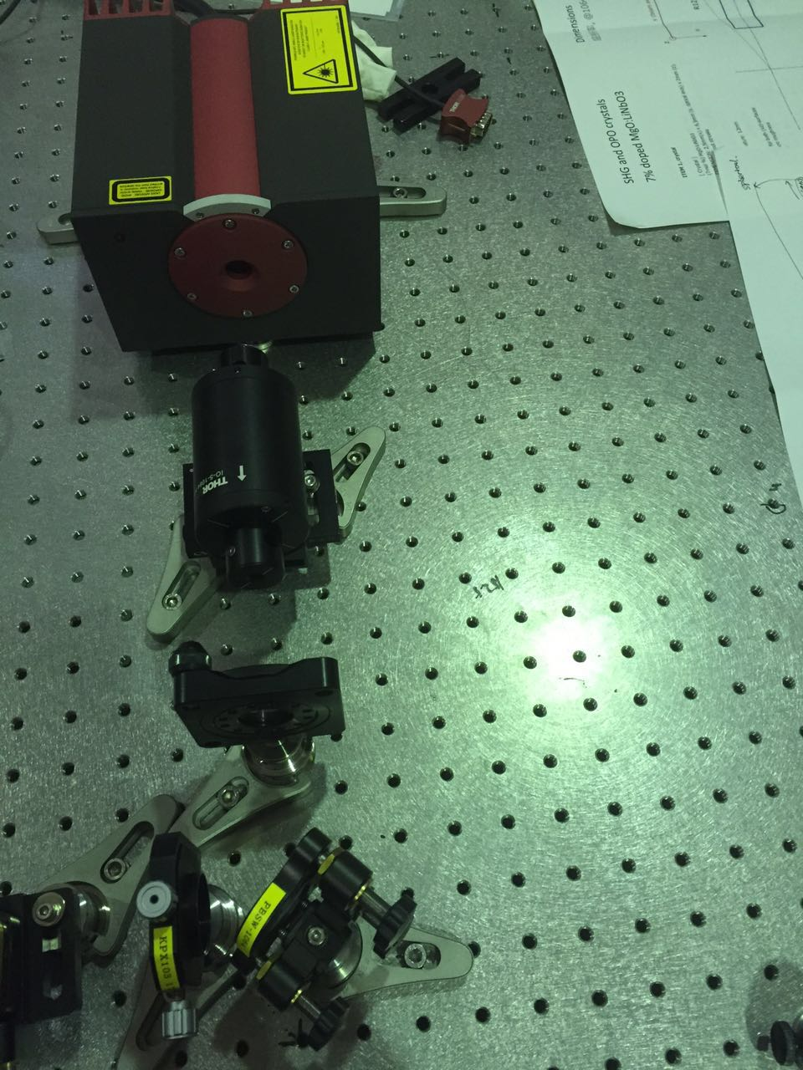
Lens(f=175mm)
Pic 3: With the equipment showing above, we test the beam size.
Although the result got from the test has some difference with the predicted value, it is not too much and have the same trend with the prediction when we change the two variables.

